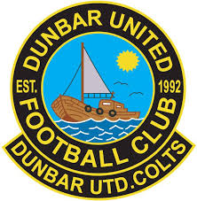

DUNBAR UNITED COLTS FC
COVID-19 TRAINING REGISTER – TEST AND PROTECT PROTOCOL
 | PLAYER NAME | PARENT/SPECTATOR NAME | COACH NAME
1
2
3
4
5
6
7
8
9
10
11
12
13

TRAINING DATE & TIME:
TRAINING LOCATION:
LEAD AGE GROUP SIGNATURE:
AGE GROUP:

DUNBAR UNITED COLTS FC - TEST AND PROTECT PROTOCOLS
If someone who has attended your club activity develops symptoms of COVID-19, they should be directed to follow the Scottish Government’s ‘test and protect’ guidelines, which can be read on the www.nhsinform.scot website
• Ensure an accurate register, including contact details, is kept for EVERY session. This register should be held by both the appropriate COVID Co-ordinator and Team COVID Co-Ordinator until advised otherwise.
• Ensure all club members are aware of who their relevant COVID Co-ordinator is, should they have to pass on their details to a member of the NHS Scotland Test & Protect team. The Club Covid Coordinator is Jamie Chapman, info@dunbarcolts.com, 07943 569315
Registers must be emailed to Jamie as soon as possible after each session.
• It is not the responsibility of the football club to inform members if someone at the club has tested positive for COVID-19. This will be done by the NHS Scotland Test & Protect team. An individual’s right to privacy must be observed.
• The football club will be expected to be able to pass on contact details of all attendees should they be asked by a member of the NHS Scotland Test & Protect team. Coaches should ensure an up to date contact list is maintained.
• Data protection guidance should be followed at all times and personal details not held for any longer than is necessary.

